**Livecoding Schritte**

1. Helper extends SQLiteOpenHelper, alt+enter, alt+enter
2. 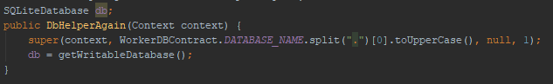
3. onCreate() -> activity, dann worker, dann image createn
4. onUpgrade() -> droppen, dann onCreate()
5. onDestroy() -> db.close()
6. insertData returns id (long)



1. 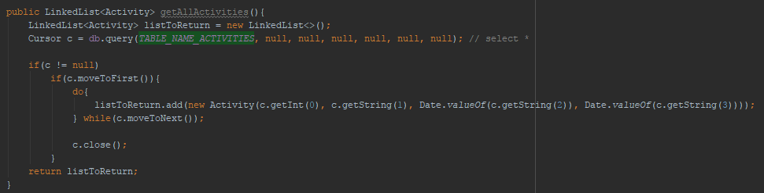getAll<Entity>
2. getAllWorkers: unbedingt allActivities vorher mitübergeben!
   1. Sonst cursor -1
   2. Fian oasch
3. Im Fragment:
   1. Initializedb -> inserts
   2. getDataFromDB -> getAll Entities
   3. fill views with data

**CONTENTPROVIDER**

Neue Klasse extends ContentProvider

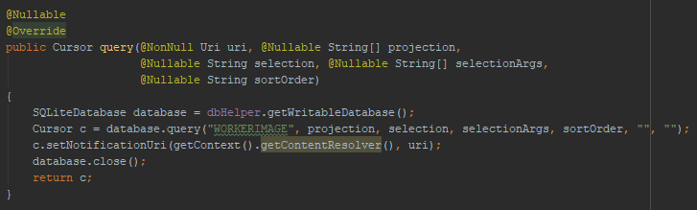Dbhelper -> onCreate = new Dbhelper

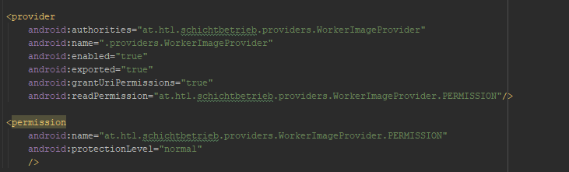Androidmanifest:

Abfrage: